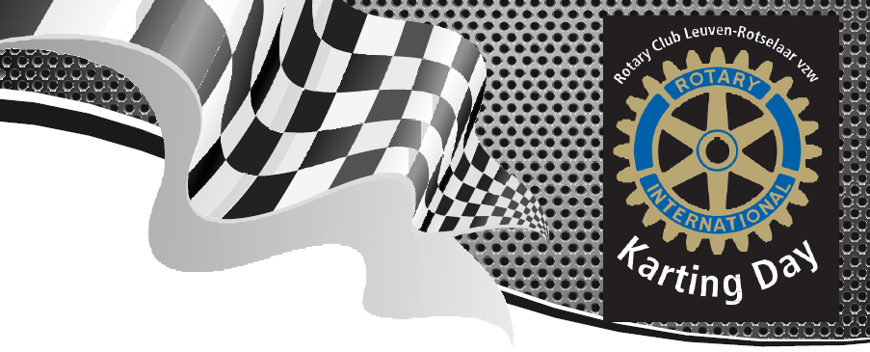

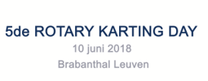

info : [karting@rotaryleuven-rotselaar.be](mailto:karting@rotaryleuven-rotselaar.be)

<https://www.facebook.com/rotarykartingday/>